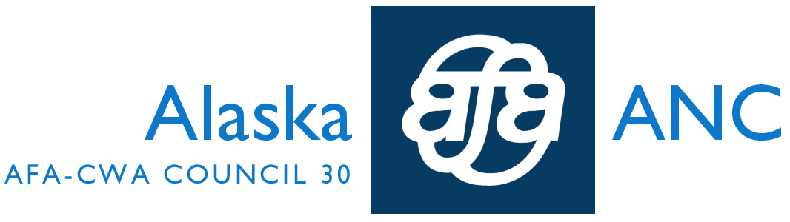 ANC Council Newsletter -- June
Dear Anchorage Co-Workers:
June was another busy month – I can’t believe how quickly time is flying by!
CrewCare: Please remember – The CrewCare form (found online at Alaskasworld.com in our Inflight area) is the appropriate venue for providing feedback – good and bad – regarding your layover hotel AND transportation issues to and from. Oftentimes, this information is shared with co-workers or your LEC but Management, time and time again, has informed us that they NEED us to complete the CrewCare form in order to attempt to get any issues resolved! Please reach out to Dori Marron – Hotel Committee Chair, if you have questions or need assistance in logging into CrewCare.
“A Tale of Two Cities: My project of sharing layover information to all is getting off to a very slow start, most likely because I chose two not-so-popular destinations: San Jose and Sitka. Betsy Demay so very graciously shared her knowledge of Sitka and I went on two layovers to San Jose to see what I could come up with. My intention is to share whatever I can, late next week, and to start the next Tale – Honolulu and Las Vegas! Please feel free to text or email me (mailfordori@yahoo.com) with any information you would like to share, however small or large. Thank you for your help – In order to succeed, we NEED your input! Thanks!”
~Dori M
Fatigue/ASAP: As we all know, we presently do not have a “fatigue policy.” If you do not feel well enough to continue on a trip (i.e., extremely noisy layover hotel, unusually long duty day followed by a short layover, etc.), you have the option of calling in sick on line, although we strongly encourage you to submit an ASAP report to document the occurrence.
RingCentral Go Live: Watch for the “Coming Soon Email Blast!” Soon, we will have just one number to remember, to get all of our AFA questions answered!
Supplemental Benefits – 2014 Enrollment: From August 12th – 14th, National Group Protection (NGP) will be in Anchorage Inflight to educate with regard to the AFA Supplemental Benefit Plans (Accident, Critical Illness and Whole Life). There will be a Benefits Counselor available onsite to enroll or make changes to your existing coverage. There are some enhancements/upgrades this year, so you are encouraged to sit down with the Counselor to review the options available.
Supplemental – these plans supplement any existing coverage
Voluntary – members choose to participate
Limited Underwriting – no medical or physical exams required
Family Coverage – available with all of the plans
Portable – members can continue coverage if they leave the company
Payroll deduction – premiums are paid through payroll deduction
If you have any questions regarding the upcoming enrollment, please contact National Group Protection (NGP) at 800-344-9016.
MEC Meeting and Negotiating Committee Training: Your MEC met on June 23rd and 26th and attended training with the Negotiating Committee on June 24th and 25th. During the training session, we had a chance to participate in a mock negotiation and, as Laura Masserant said concerning our Negotiating Team: “This team is tough, united and ready to rumble!” Ben Minicucci, Andy Schneider, Elizabeth Ryan and Mike Link met with the MEC and the Negotiating Committee to discuss the executive summary from the Flight Attendant Survey. (As a reminder, this summary was recently blasted to all members, but if you missed it, you can find it posted at alaskamec.org, under negotiations-update-june-26-2014.)
For those of you already wearing your RED HOT AFA PINS – thank you! As we move into the next mediation session, it is imperative that we show our solidarity – WE ARE FIVE BASES STANDING STRONG! As a reminder to our new hire Flight Attendants, the RED AFA pin is our official pin, and you ARE allowed to wear it!
Upcoming Summer Events to look forward to:
RED HOT AFA Summer BBQ at Angle Lake Park in SeaTac, WA – right next to the Alaska Airlines Corporate Headquarters! The picnic will be on Wednesday, August 20th, in the afternoon. All Flight Attendants throughout the system are encouraged to attend and may utilize non-revenue travel to attend this recreational and educational event!
AFA will also be conducting a system-wide solidarity activity at each of our Bases on August 27th! For maximum impact, we are going to withhold details for now, but stay tuned for more information!
Remember, the next scheduled event will be held on Tuesday, July 22nd. In Anchorage, our event time will be from 1:00 to 4:00 pm. We will be doing another airport walk and handing out the latest and greatest swag! If you cannot attend our event in Anchorage, other Base events are as follows:
Seattle: 5 to 9 am; 11 am to 4 pm and 5 pm to 10 pm
Portland: 5:30 to 8:00 am and 8:00 to 10:30 am
Los Angeles: 5 to 8:30 am, 8:30 am to Noon and 1 to 4:30 pm
San Diego: 8 am to 11:30 am.
Please contact Thresia Raynor (907-952-0639) to volunteer or for further information.
During this RED HOT Summer, your Negotiating Committee and your MEC asks that you stay informed, stay connected and show your solidarity! We are only as strong as our members, and we need ALL of our members STANDING STRONG!
In Solidarity,
Becky, Lisa and Jan
Your LEC Officers

