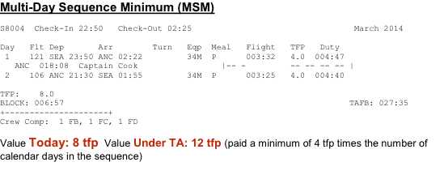
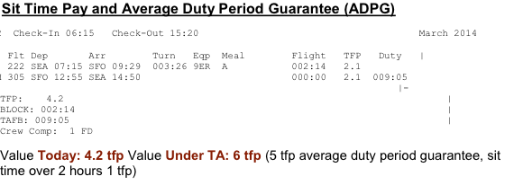
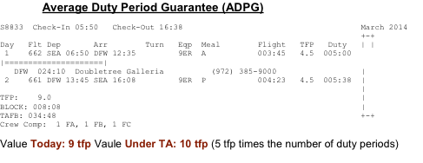
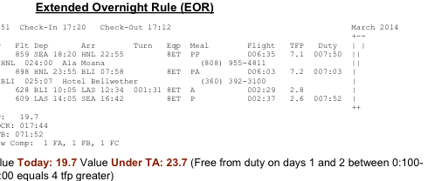

Average Duty Period Guarantee
L7111 Check-In 16:10 Check-Out 09:21 February 2014
+---------------------+
Day Flt Dep Arr Turn Eqp Meal Flight TFP Duty
1 561 LAX 17:10 PDX 19:32 8ET 002:22 2.5 003:37
PDX 010:13 Shilo Inn
2 560 PDX 06:45 LAX 09:04 000:51 739 A 002:19 2.5
2 707 LAX 09:55 YVR 12:52 739 A 002:57 3.1 007:07
YVR 016:08 Hilton Vancouver A/P
3 708 YVR 06:00 LAX 08:51 739 A 002:51 3.1 004:06

TFP: 13.6
BLOCK: 010:29
TAFB: 041:11
Crew Comp: 1 FD
Value Today: 13.6 TFP. Value Under TA: 15.0 TFP (5.0 average duty period guarantee x 3 duty periods = 15 TFP)

Average Duty Period Guarantee, Sit Time Pay
B7202 Check-In 06:00 Check-Out 22:23 February 2014
Day Flt Dep Arr Turn Eqp Meal Flight TFP Duty
1 539 BUR 07:00 SEA 09:35 002:40 73H A 002:35 2.7
1 324 SEA 12:15 SJC 14:18 8ET 002:03 2.1 008:33
SJC 023:52 Hilton San Jose
2 329 SJC 15:10 SEA 17:14 002:21 8ET 002:04 2.1
2 520 SEA 19:35 BUR 21:53 73G P 002:18 2.7 007:58

TFP: 9.6
BLOCK: 009:00
TAFB: 040:23
Crew Comp: 1 FA, 1 FB, 1 FC
Value Today: 9.6 TFP. Value Under TA: 12.0 TFP (5.0 average duty period guarantee, 2 x sit time over 2 hours = +1 TFP additional)

Average Duty Period Guarantee, Sit Time Pay
L7270 Check-In 07:00 Check-Out 13:53 February 2014
Day Flt Dep Arr Turn Eqp Meal Flight TFP Duty
1 459 LAX 08:00 SEA 10:45 002:15 734 A 002:45 2.8 |=====================|
1 554 SEA 13:00 PSP 15:40 734 P 002:40 2.9 008:55
PSP 023:45 Hilton Palm Springs
2 555 PSP 16:25 SEA 19:14 000:46 734 P 002:49 2.9
2 694SEA 20:00 GEG 20:55 734 000:55 1.0 005:30
GEG 010:05
3 695 GEG 08:00 SEA 09:10 001:35 734 001:10 1.0 +
3 460 SEA 10:45 LAX 13:23 739 A 002:38 2.8 006:38

TFP: 13.7
BLOCK: 012:57
TAFB: 054:53
Crew Comp: 1 FA, 1 FB, 1 FC
Value Today: 13.7 TFP. Value Under TA: 16.0 TFP (5.0 average duty period guarantee, sit time over 2 hours = +1 TFP additional

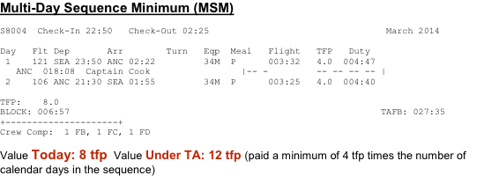
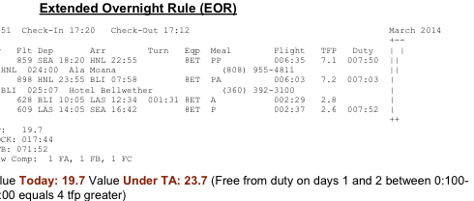

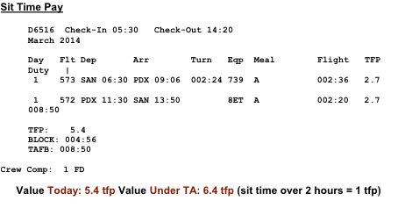
Average Duty Period Guarantee, Sit Time Pay
A5017 Check-In 13:05 Check-Out 22:45 February 2014
+---------------------+
Day Flt Dep Arr Turn Eqp Meal Flight TFP Duty
1 187 ANC 14:05 FAI 15:04 000:46 34M P 000:59 1.0
188 FAI 15:50 ANC 16:54 002:13 34M 001:04 1.0
45 ANC 19:07 BET 20:20 000:50 34M 001:13 1.4
1 46 BET 21:10 ANC 22:15 34M P 001:05 1.4 009:40

TFP: 4.8
BLOCK: 004:21
TAFB: 009:40
Crew Comp: 1 FB, 1 FC, 1 FD
Value Today: 4.8 TFP. Value Under TA: 6.0 TFP (5.0 average duty period guarantee, sit time over 2 hours after second leg = 1 TFP additional)
Extended Overnight Rule
A5016 Check-In 10:35 Check-Out 03:16 February 2014
Day Flt Dep Arr Turn Eqp Meal Flight TFP Duty | S M T W T F S |
1 64 ANC 11:35 JNU 13:12 000:48 34M A 001:37 1.8
64 JNU 14:00 PSG 14:50 000:40 34M 000:50 1.0
64 PSG 15:30 WRG 15:55 000:45 34M 000:25 1.0
64 WRG 16:40 KTN 17:12 000:42 34M 000:32 1.0
1 64 KTN 17:54 SEA 20:39 34M P 001:45 2.1 009:19 SEA 026:11 Hilton Seattle A/P
2 121SEA 23:50 ANC 02:46 34M P 003:56 4.0 005:11
TFP: 10.9
BLOCK: 009:05
TAFB: 040:41
Crew Comp: 1 FB, 1 FC, 1 FD
Value Today: 10.9 TFP. Value Under TA: 14.9 TFP (2 duty periods over 3 calendar days = 2 duty periods over 3 calendar days x 4 TFP = 12 TFP minimum; free from duty 01:00-23:00 during layover = 4 TFP additional is greater)

Average Duty Period Guarantee, Sit Time Pay
B7202 Check-In 06:00 Check-Out 22:23 February 2014
Day Flt Dep Arr Turn Eqp Meal Flight TFP Duty
1 539 BUR 07:00 SEA 09:35 002:40 73H A 002:35 2.7
1 324 SEA 12:15 SJC 14:18 8ET 002:03 2.1 008:33
SJC 023:52 Hilton San Jose
2 329 SJC 15:10 SEA 17:14 002:21 8ET 002:04 2.1
2 520 SEA 19:35 BUR 21:53 73G P 002:18 2.7 007:58

TFP: 9.6
BLOCK: 009:00
TAFB: 040:23
Crew Comp: 1 FA, 1 FB, 1 FC
Value Today: 9.6 TFP. Value Under TA: 12.0 TFP (5.0 average duty period guarantee, 2 x sit time over 2 hours = +1 TFP additional)

Multi-Day Sequence Minimum
A5032 Check-In 20:40 Check-Out 03:18 February 2014
Day Flt Dep Arr Turn Eqp Meal Flight TFP Duty
1 106 ANC 21:40 SEA 02:03 34M P 003:23 4.0 004:38
SEA 020:47
2 121SEA 23:50 ANC 02:48 34M P 003:58 4.0 005:13

TFP: 8.0
BLOCK: 007:21
TAFB: 030:38
Crew Comp: 1 FB, 1 FC, 1 FD
Value Today: 8.0 TFP. Value Under TA: 12.0 TFP (2 duty periods over 3 calendar days x 4 TFP = 12 TFP minimum)

Multi-Day Sequence Minimum
P6158 Check-In 21:25 Check-Out 07:39 February 2014

Day Flt Dep Arr Turn Eqp Meal Flight TFP Duty
1 145 PDX 22:25 ANC 01:25 73H P 004:00 4.2 005:15
ANC 024:15 Captain Cook (907) 276-6000
3 130 ANC 02:40 PDX 07:09 8ET A 003:29 4.2 004:44

TFP: 8.4
BLOCK: 007:29
TAFB: 034:14
Crew Comp: 1 FD
Value Today: 8.4 TFP Value Under TA: 12.0 TFP (2 duty periods over 3 calendar days x 4 TFP = 12 TFP minimum)

Extended Overnight Rule
P6143 Check-In 17:40 Check-Out 07:57 February 2014

Day Flt Dep Arr Turn Eqp Meal Flight TFP Duty
1 863 PDX 18:40 OGG 22:55 8ET PP 006:15 6.8 007:30
OGG 024:00 Wailea Beach Marriott R&S
2 822OGG 23:55 PDX 07:27 8ET P 005:32 6.8 006:47 |
TFP: 13.6
BLOCK: 011:47
TAFB: 038:17
Crew Comp: 1 FD
Value Today: 13.6 TFP. Value Under TA: 17.6 TFP (free from duty 01:00-23:00 during overnight = 4 TFP additional)

Sit Time Pay

P6045 Check-In 05:45 Check-Out 15:20 February 2014

Day Flt Dep Arr Turn Eqp Meal Flight TFP Duty 1 560 PDX 06:45 LAX 09:05 003:20 739 002:20 2.5
1 569 LAX 12:25 PDX 14:50 9ER P 002:25 2.5 009:35

TFP: 5.0
BLOCK: 004:45
TAFB: 009:35
Crew Comp: 1 FD

Value TODAY: 5.0 TFP. Value UNDER TA: 6.0 TFP (sit time over 2 hours = + 1 TFP additional)

Average Duty Period Guarantee, Sit Time Pay
P6135 Check-In 14:45 Check-Out 22:40 February 2014
+---------------------+
Day Flt Dep Arr Turn Eqp Meal Flight TFP Duty
1 DH2517PDX 15:45 SFO 17:45 002:50 P 000:00 1.8
1 235 SFO 20:35 PDX 22:10 8ET 001:35 1.8 007:55

TFP: 4.0
BLOCK: 001:35
TAFB: 007:55
Crew Comp: 1 FD
Value Today: 4.0 TFP. Value Under TA: 6.0 TFP (5.0 average duty period guarantee, sit time over 2 hours = + 1 TFP additional)

