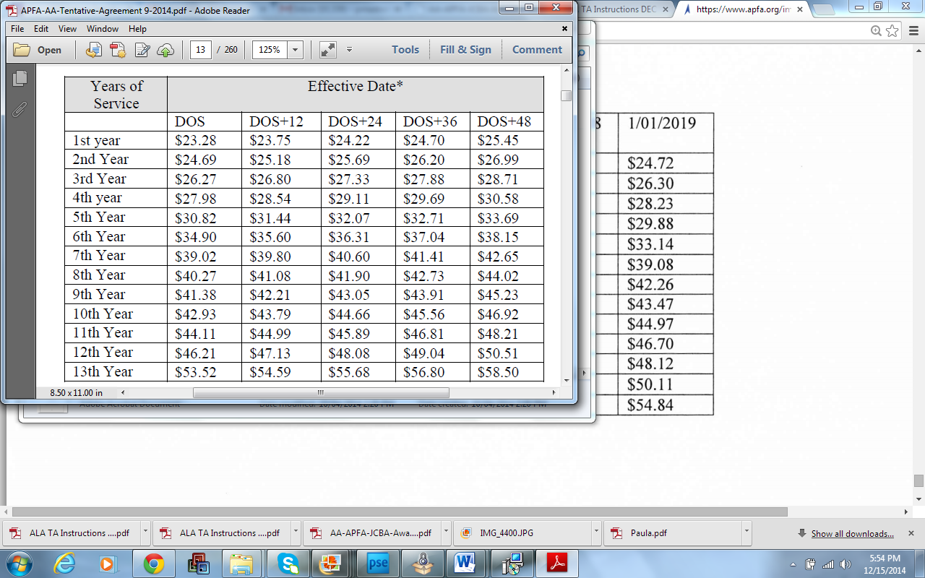

**AA/ US Airways TA Rates -September 2014 (TA Failed)**

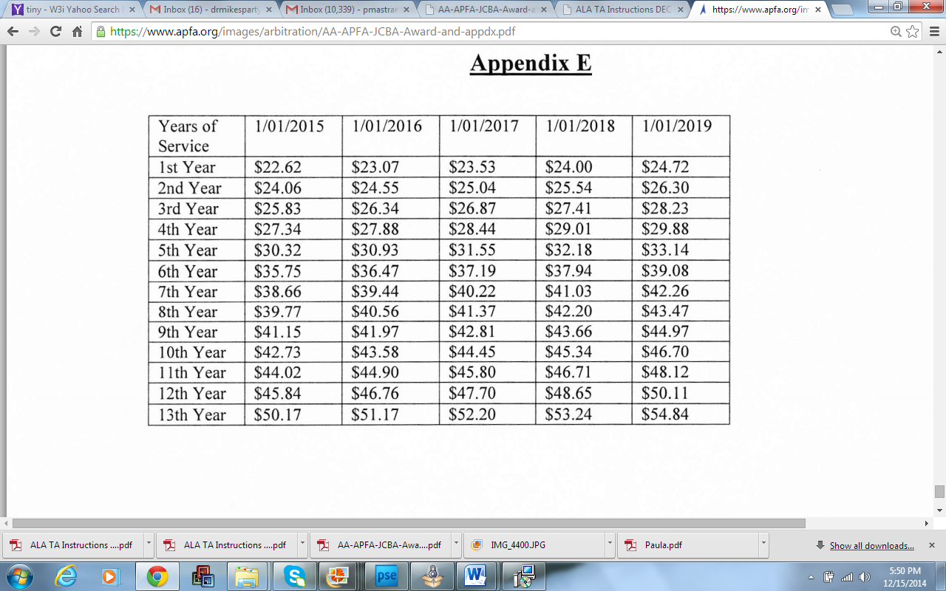

**AA/ US Airways ARBITRATION AWARD – December 2014**



**ALASKA TA Rates Converted to Block Hours**